**BEEE Question Bank for IT 2**

Q1. Explain

1. Waveform .
2. Cycle .
3. Alternation .
4. Frequency
5. Time period
6. Relation between f and T
7. Phase
8. Phase difference
9. Lead and lag
10. Power factor
11. Active power
12. Reactive power
13. RMS value
14. Peak value
15. Average value
16. Form factor
17. Peak factor

Q2. State the theorem and determine current through 20 Ohms resistor using

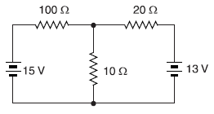

1. Superposition Theorem
2. Thevenin’s Theorem
3. Norton’s Theorem

Q3. Calculate the value of R which will absorb maximum power from the circuit of Fig. Also find the value of maximum power.

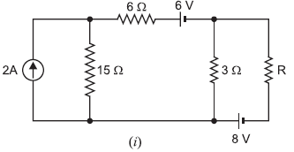

Q4. Three circuits in parallel take the following currents:

i1 = 50 sin 188 t ;

i2 = 60 sin (188 t − π/4) ;

i3 = 30 cos (188 t + π/3)

Find the expression for the resultant current, its r.m.s. value and frequency.

Q5. The current in a circuit is given by (4.5 + j12) A when the applied voltage is (100 + j150) V. Determine (i) the magnitude of impedance and (ii) phase angle.